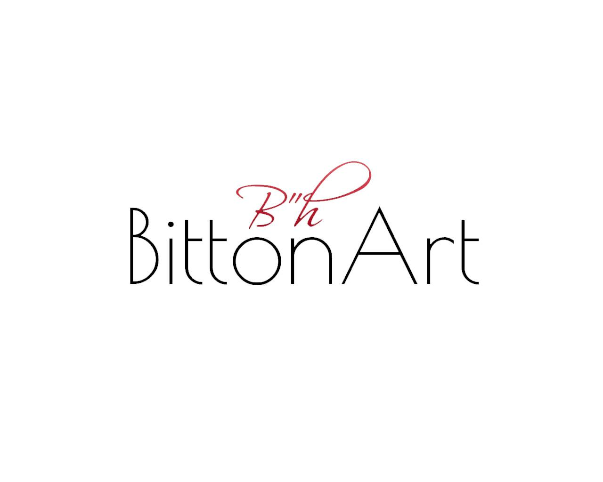

Haena Chen Bitton,
A local Floridian originally from Israel, self taught artist, and celebrated art curator. Since I was a child I was truly fascinated with all forms of visual creative expressions. Personal works of art utilize acrylic mediums to form abstract, figurative expressions through a release of feelings, and thoughts portraying a personal sentiment. From free flowing, abstract, figurative to pop art, my various styles open up the viewer to a world of curiosities! I enjoy freeing myself through my art showcasing my innate response to the interaction we face as humans with the world and society's influence on mankind's state of reality. Creating thought provoking art which not only serves as a decoration but also carries with it an intelligent conversation with a wealth of context and a particular message to its present beholder. My art speaks to me and alongside the visual form, I enjoy writing poems about my creations that go along with my art. I find true joy in connecting and de-constructing the dots of a story, discovering things which were not always seemingly ther, yet have always belonged.

BittonArt was founded a year ago and in a very short time built a tremendous following with no financial backing and paid ads, organic true followers within the art community and in and around fort lauderdale. Our collective is mainly local artists that are emerging which have tremendous potential to become full time artists. Their artworks are all contemporary, thought provoking and enhance and match the miami vibes and scenes. Our collective is composed of unique, hardworking passionate individuals that have built a name and presence to themselves in and around south florida. None have a permanent place to display and sell their artworks. Our artworks range from different price points $800-35k all artworks are originals and no copies have been made or distributed.
BittonArt is an online platform which broadcasts all artworks virtually online and hosts popup art events around town. Our latest project was the “ArtMobile” an HD Screen art show exhibit combining visual arts with music and touches the masses by showcasing in fun spots around town such as “Tommy Bahamas Marlins Bar” in Las Olas. BittonArt, helps the artists write art descriptions, title the artworks, and guides the artist in inspiration and art direction. Posts are made on a weekly basis on instagram @BittonArt and on facebook. There have been numerous articles in written publications and television interviews about my art events, art shows and art projects such as LifeStyle Magazine, Palm beach illustrated, Sun-Sentinel, American Airlines, WSFLTV, Voyage Miami, and the Forbes,.
BittonArt Included Artworks
Haena Chen Bitton
Anthony Bourdain
Adam and Eve
Merkava
Artem

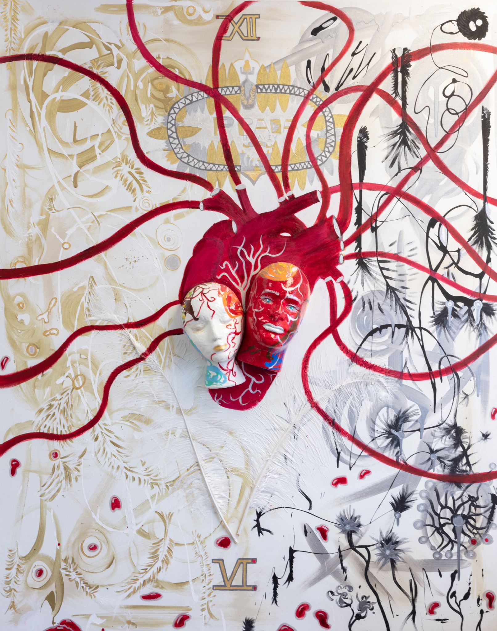
Mixed media

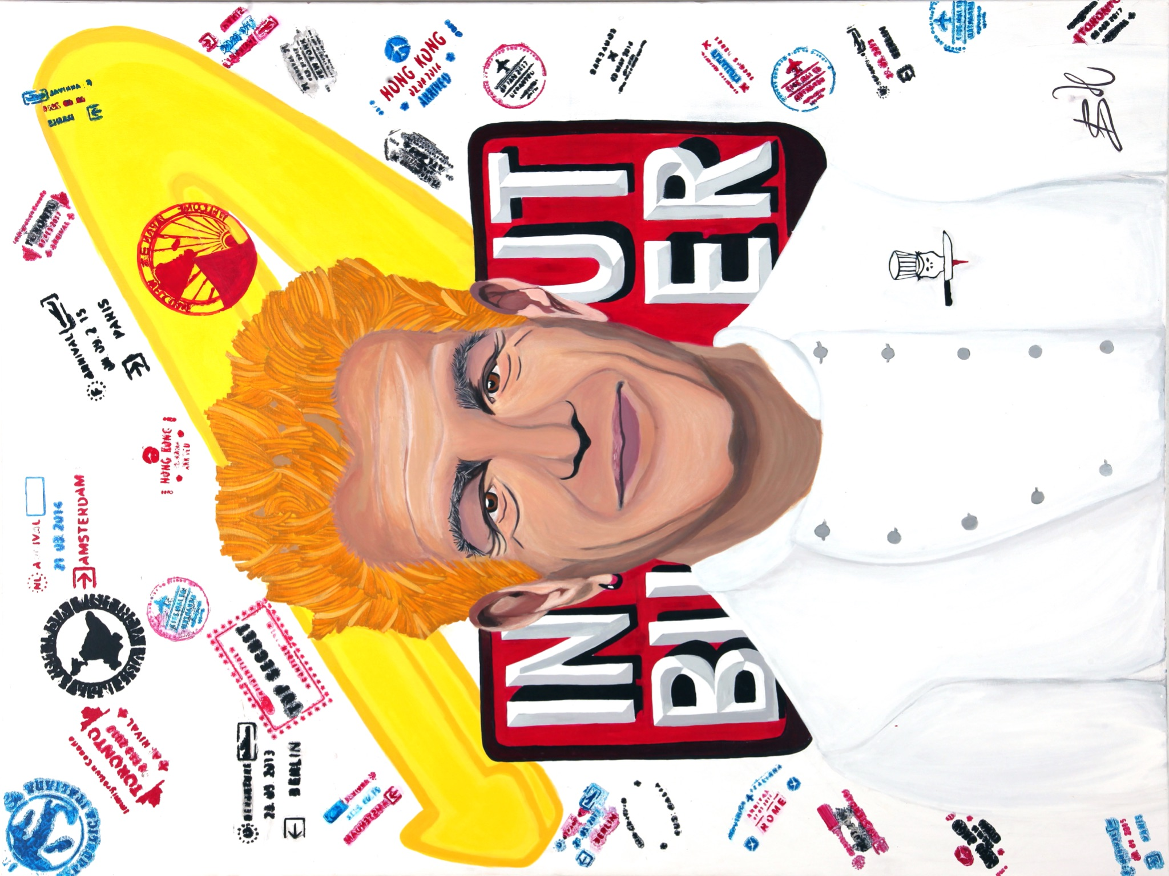

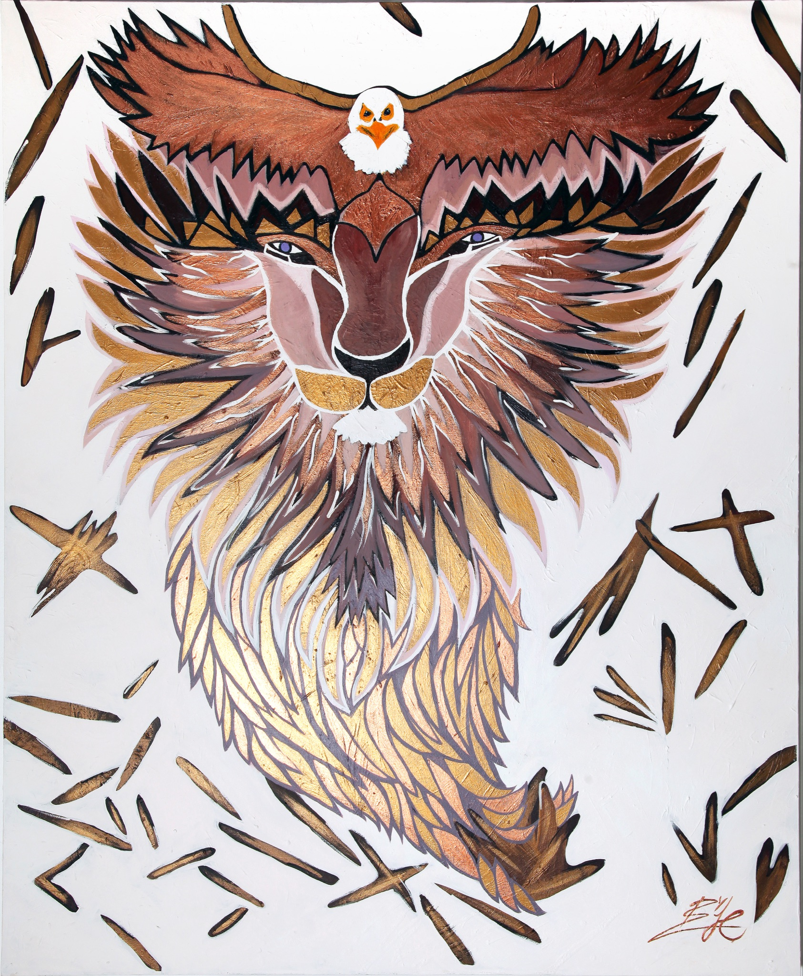

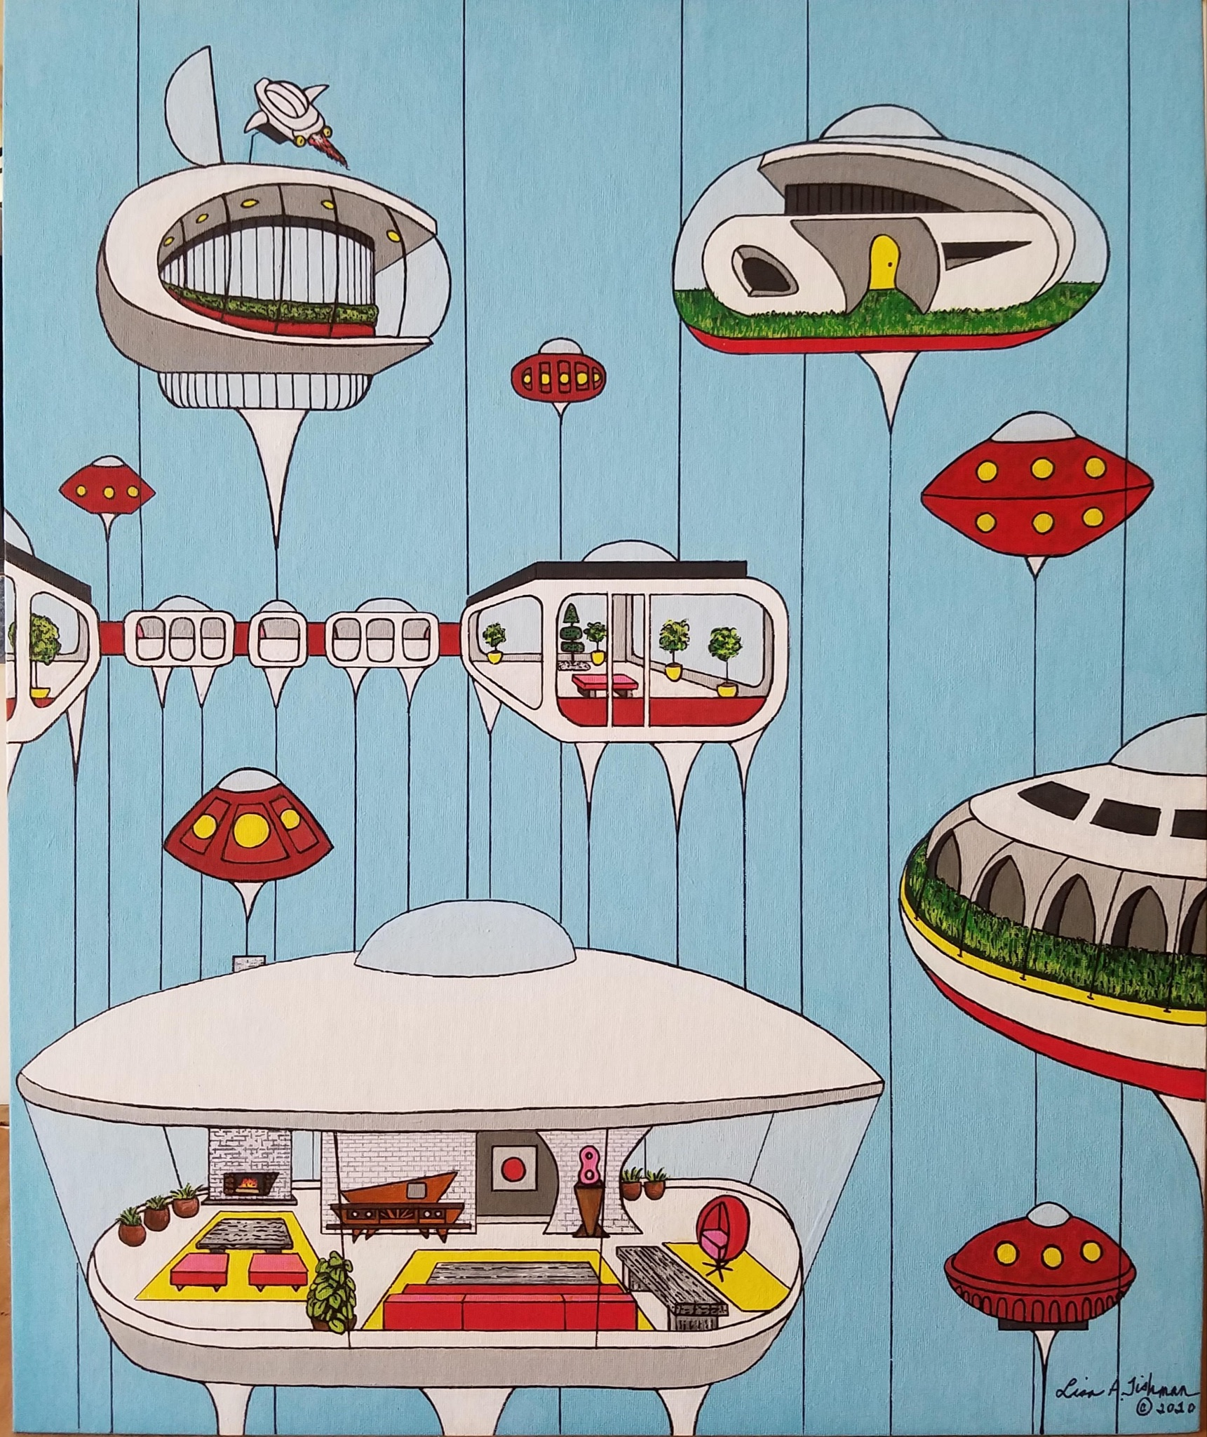
Lisa Tishman
Watercolors ink

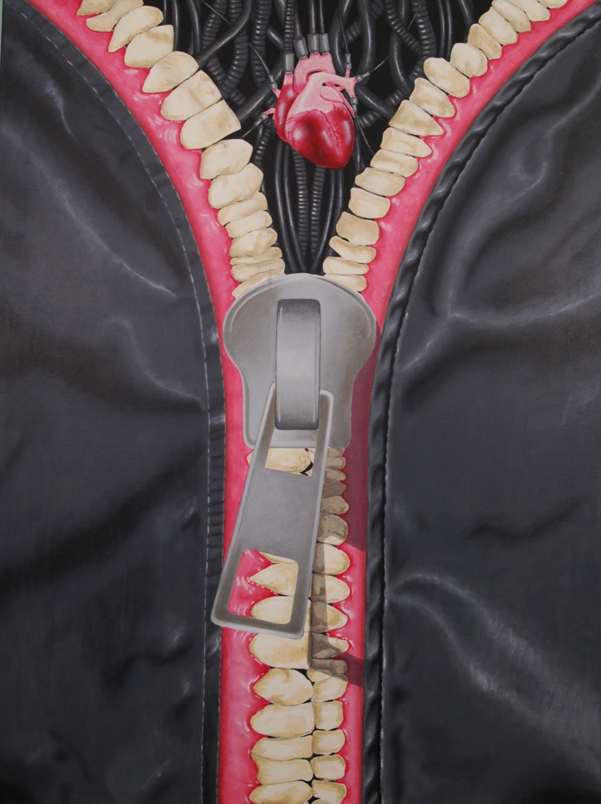
Joey aka The Unsalted Life

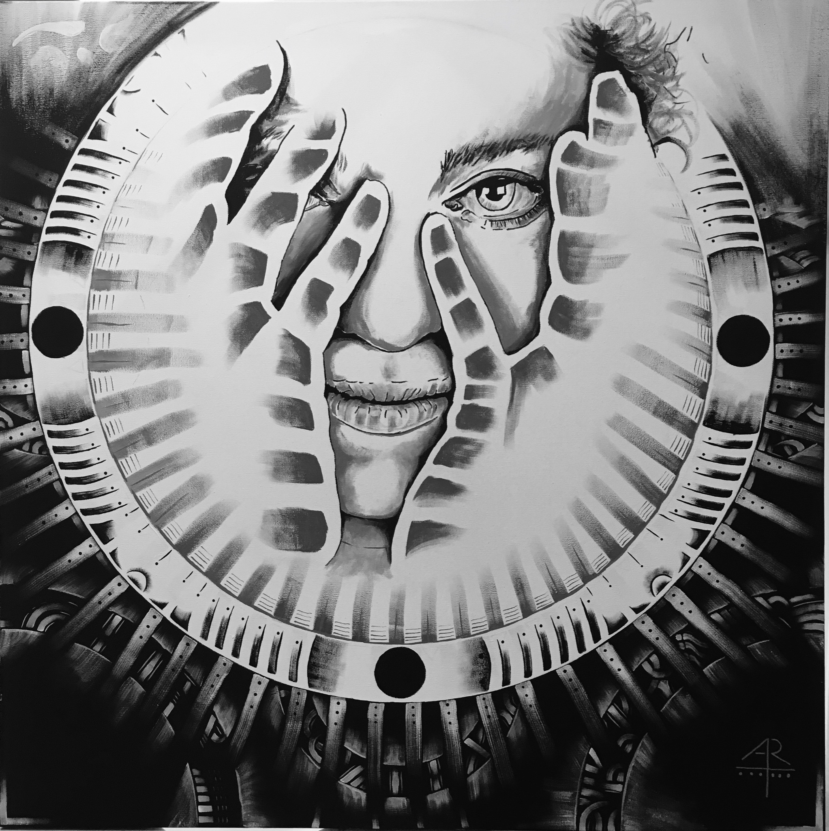
Artem khourchoudian aka art_dian

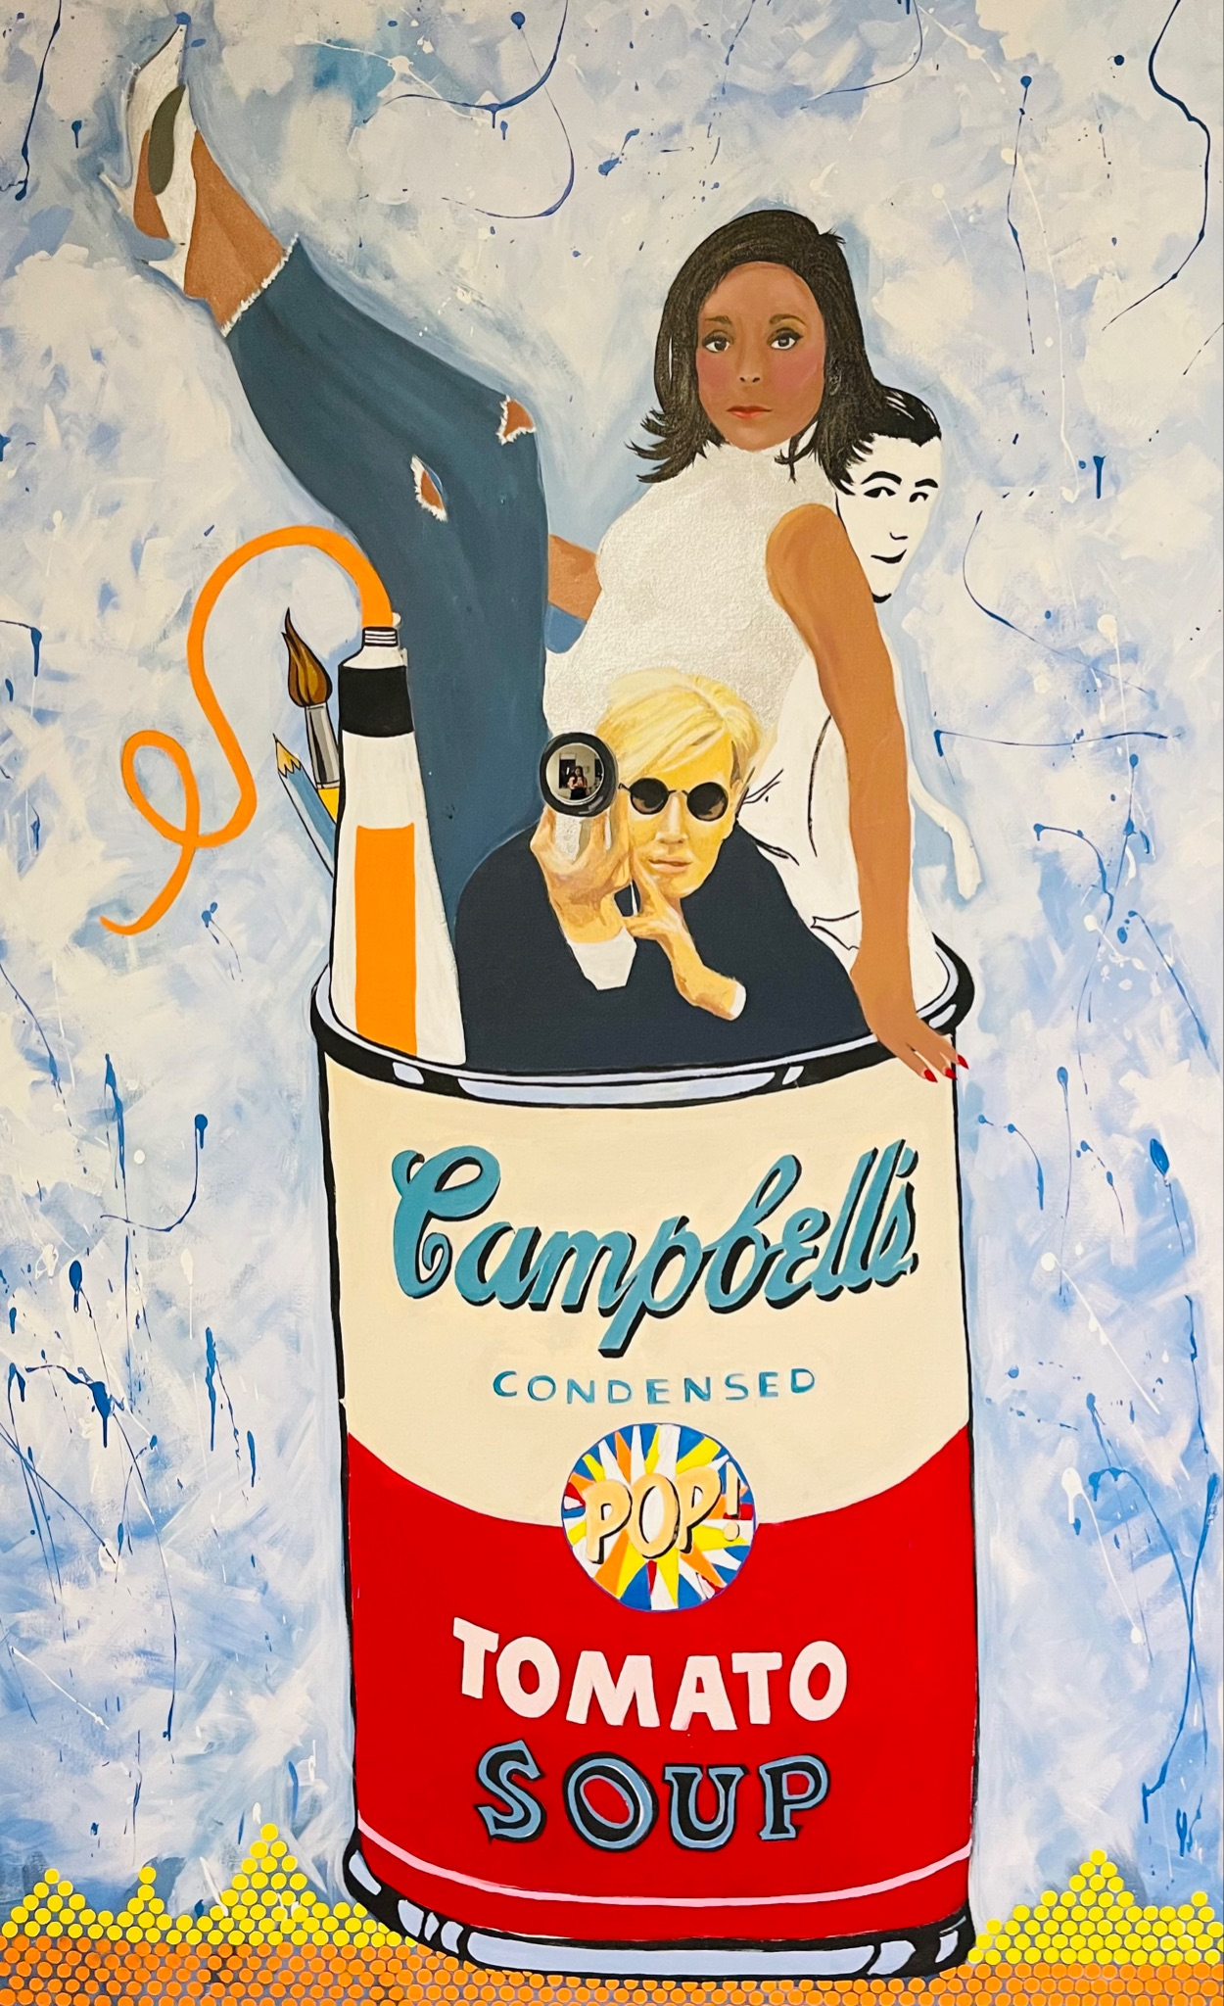
Haena and Joey The Unsalted Life

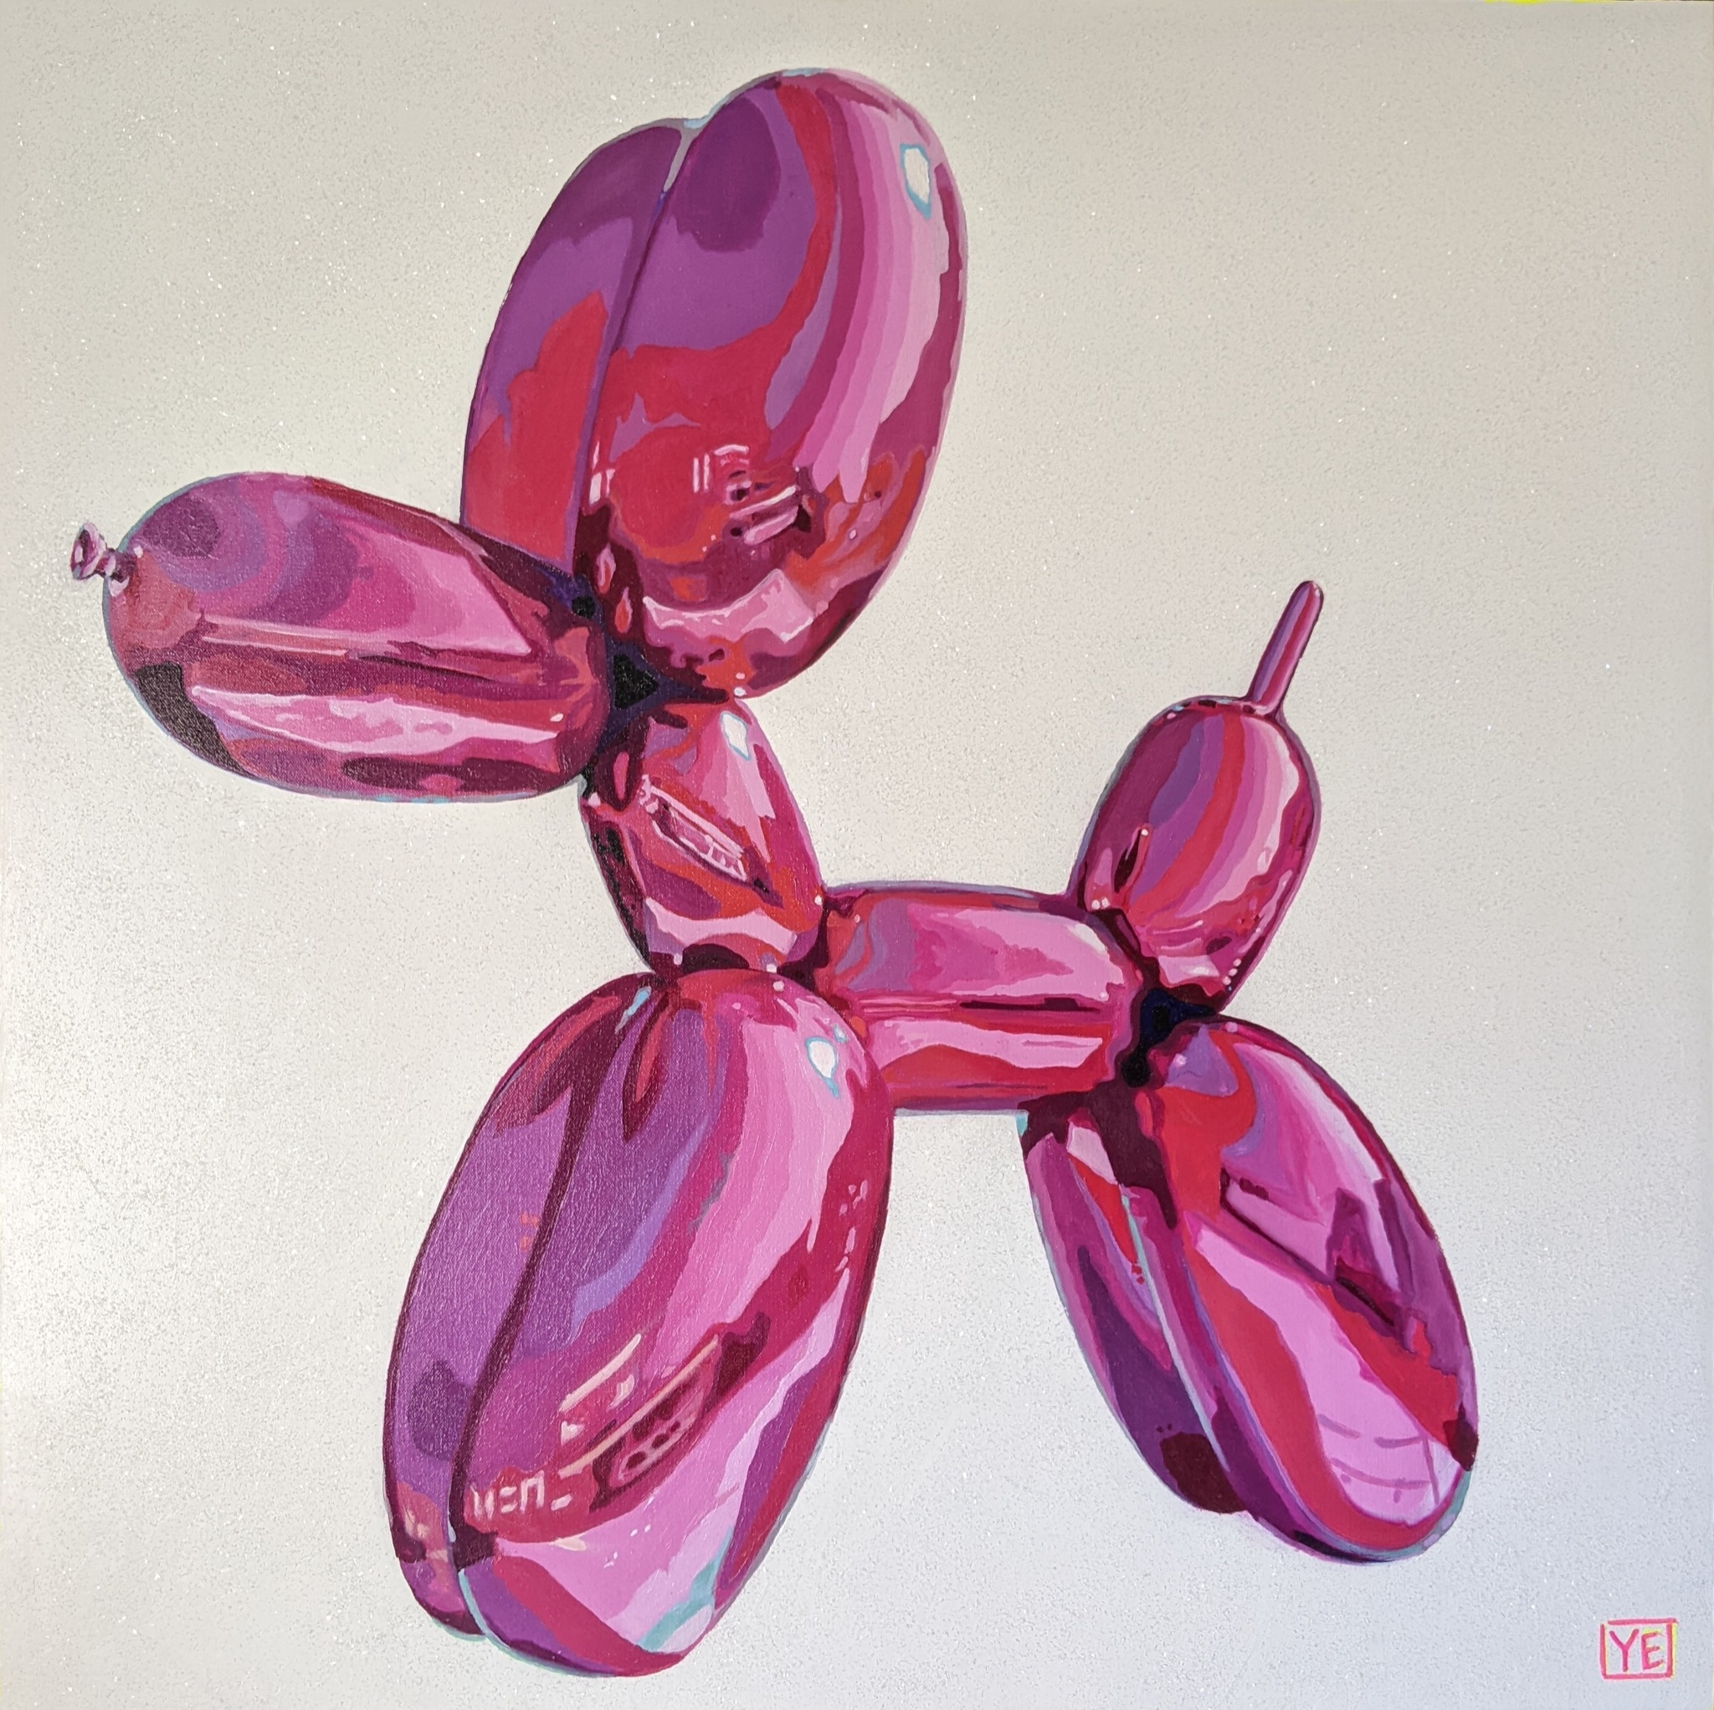
Yidiah Exposito
Mixed media

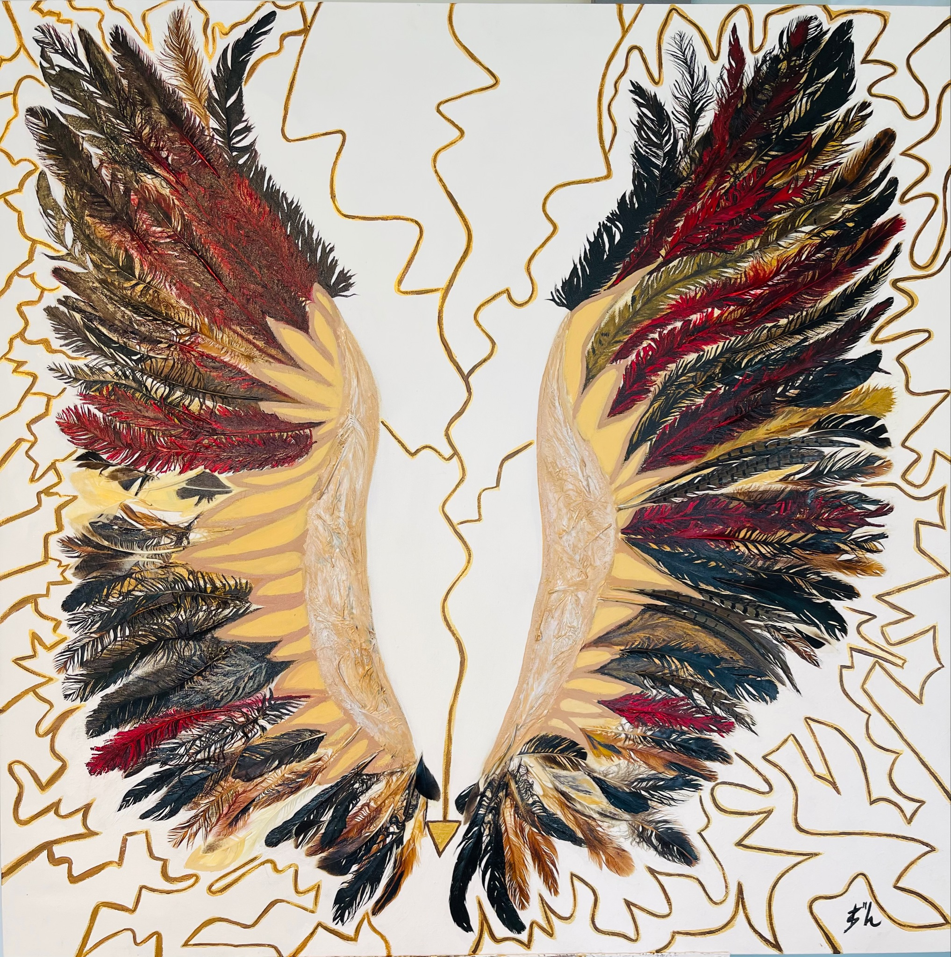
Limb-OH!
Mixed media

